Lab Objective

Configuring a Stub Zone

**Lab Procedures**

**1.** On RWDC01, go to the DNS Manager console. Right-click Forward Lookup Zones, and click New Zone.

**2.** When the New Zone Wizard begins, click Next.

**3.** When the Zone Type page opens, select the Stub zone radio button and click Next.

**4.** On the Active Directory Zone Replication Scope page, click Next.

**5.** On the Zone Name page, type **litware.com** in the Zone name text box, and then click Next.

**6.** On the Master DNS Servers page, type **192.168.1.60** and press the Enter key. Click Next.

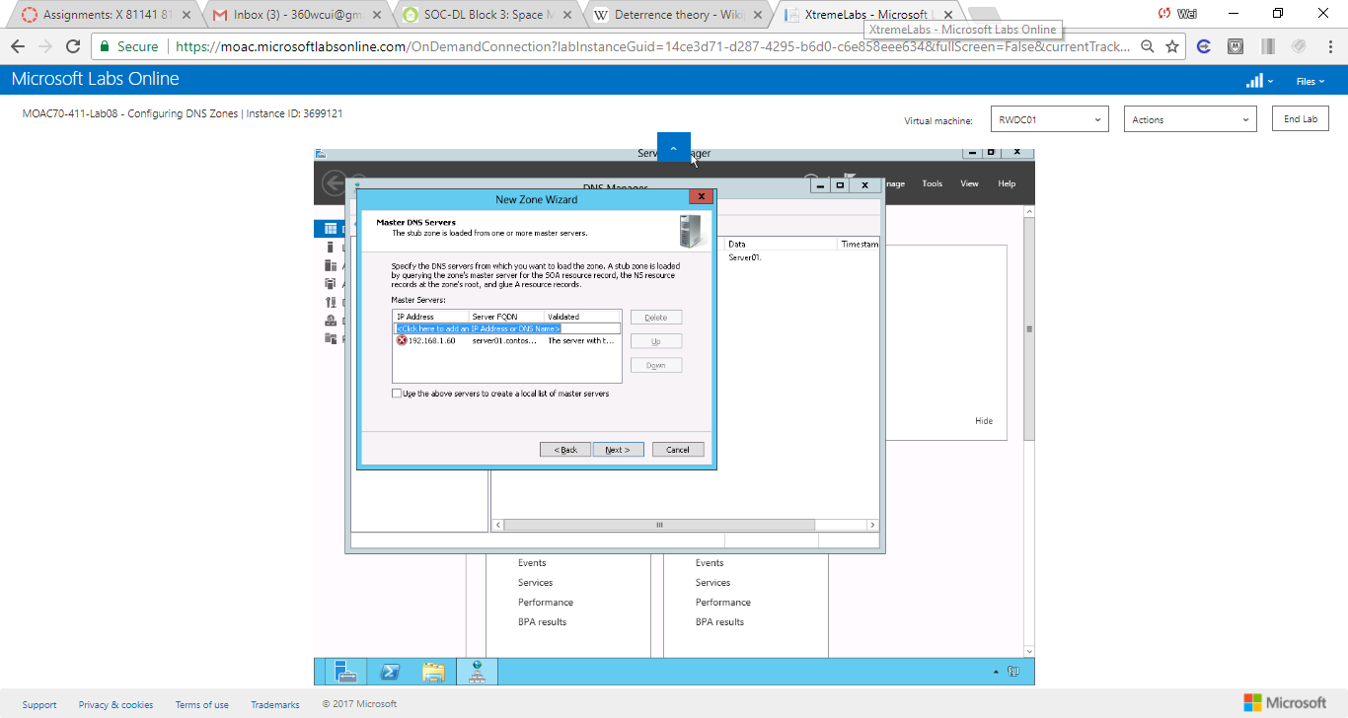

Figure 1 On the Master DNS Servers page, type 192.168.1.60 and press the Enter key. Click Next

**7.** When the Completing the New Zone Wizard displays, click Finish.

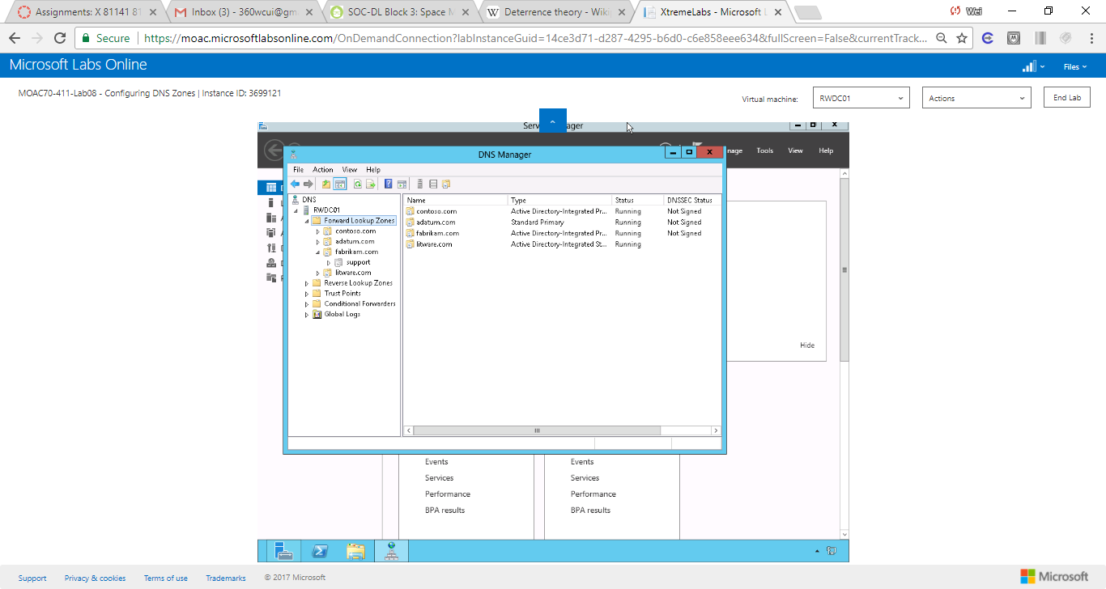

Figure 2 When the Completing the New Zone Wizard displays, click Finish

**8.** On Server01, go to the DNS Manager console. Right-click Forward Lookup Zones and click New Zone.

**9.** When the New Zone Wizard, click Next.

**10.** On the Zone Type page, click Next.

**11.** On the Zone Name page, type **litware.com** and click Next.

**12.** On the Zone File page, click Next.

**13.** On the Dynamic Update page, click Next.

**14.** When the wizard is complete, click Finish.

**15.** Take a screen shot of the DNS Manager window by pressing Alt+Prt Scr and then paste it into your Lab08_worksheet file in the page provided by pressing Ctrl+V.

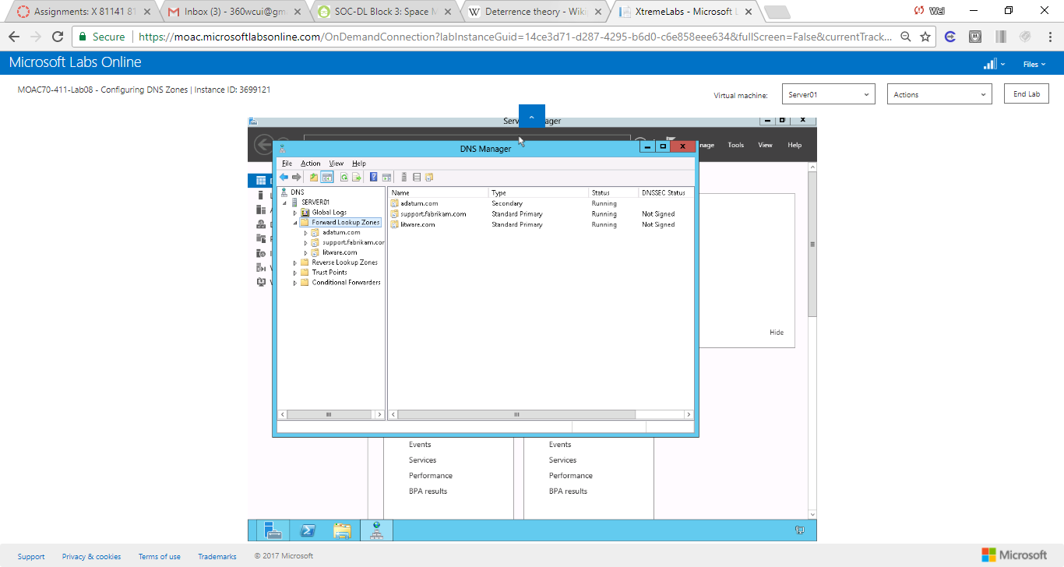

Figure 3 A screen shot of the DNS Manager window

End of exercise. You can leave the windows open for the next exercise.

**Lab Summary**

In this exercise, I created a stub zone that points directly to another DNS server. A stub zone is a copy of a zone that contains only necessary resource records (Start of Authority (SOA), Name Server (NS), and Address/Host (A) record) in the master zone and acts as a pointer to the authoritative name server.